**DEPARTMENT OF**

**ELECTRONICS AND COMMUNICATION ENGINEERING**

**College of Engineering and Technology, SRMIST**

MINI PROJECT REPORT

EVEN Semester, 2021-22

Sub. Code & Name : 18ECC202J-Linear Integrated Circuits

Year & Semester : II Year, IV sem

Project Title : Audio amplifier using op-amp

Supervisor : **Dr. K. Kalimuthu, Associate Professor, Department of Electronics and Communications Engineering.**

Team Members : Kunal Keshan - RA201100

Ganni Likhit - RA2011004010048

Mukthapuram Sivaram Chandran - RA2011004010049

| Reg. No | RA2011004010051    Kunal Keshan | RA2011004010048  Ganni LIkhit | RA2011004010049  Mukthapuram Sivaram Chandran |
| --- | --- | --- | --- |
| Mark split up |
| Novelty in the project work  (1 marks) |  |  |  |
| Level of understanding of the design formula(2 marks) |  |  |  |
| Contribution to the project  (1 Marks) |  |  |  |
| Report writing (1 Marks) |  |  |  |
| **Total (5 Marks)** |  |  |  |

Date:

**Signature of Supervisor**

**AUDIO AMPLIFIER USING OP-AMP AND POWER TRANSISTORS**

**OBJECTIVE:**

To create an Audio amplifier using op-amp, power transistors and various other passive components.

**ABSTRACT:**

Amplifiers are the backbone of Analog electronics. They are used vastly in the field of the electronics industry. Amplifiers are used almost in all audio-related applications.

The power amplifier is part of sound electronics. It is designed to maximize the magnitude of the power of a given input signal. In sound electronics, the operational amplifier increases the voltage of the signal but is unable to provide the current, which is required to drive a load.

**INTRODUCTION:**

In an amplifier chain system, the power amplifier is used at the last or final stage before the load. Generally, the Sound Amplifier system uses the below topology shown in the block diagram.

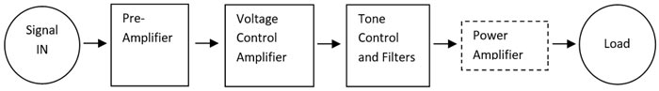

As you can see in the above block diagram, the Power Amplifier is the last stage which is directly connected to the load. Generally, before Power Amplifier, the signal is corrected using Pre Amplifiers and Voltage controls amplifiers. Also, in some cases, where tone control is needed, the tone control circuitry is added before Power Amplifier.

**HARDWARE REQUIREMENT/DESCRIPTION:**

8 Ohms 10 Watt Speaker, 4.7k Ohms Resistors, 200 Ohms Resistors, 47k Ohms Resistor, 3.2k Ohms Resistor, 10pF Capacitor, .82pF Capacitor, TIP127, TIP122 Power Transistors, IC741, Breadboard and connecting wires.

**CIRCUIT/COMPONENT SPECIFICATIONS:**

| Supply voltage (*V*CC) | -15V to +15 V |
| --- | --- |
| Supply current (*V*CC = +5 V) | 3 to 6 mA |
| Output current (maximum) | 900 mA |
| [Operating temperature](http://en.wikipedia.org/wiki/Operating_temperature) | 0 to 70 °C |

**CIRCUIT DIAGRAM:**

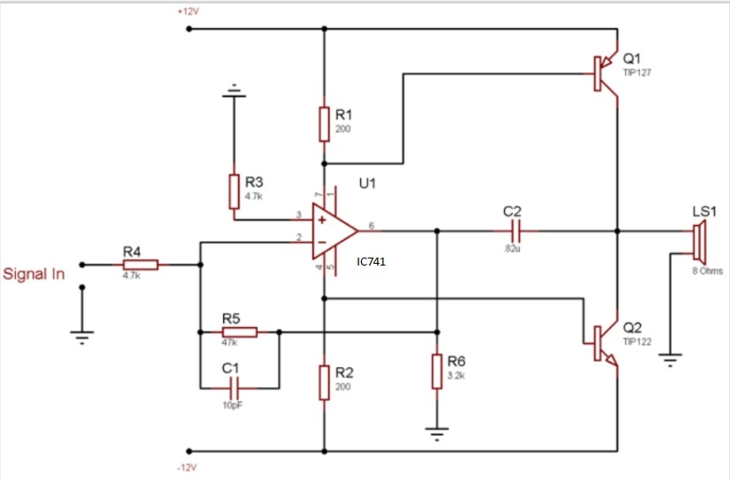

**DESIGN FORMULA:**

We used a simple formula to calculate the wattage of the amplifier,

Amplifier Wattage = V^2 / R

We connected an AC multimeter across the output. We provided a very Low-frequency sinusoidal signal of a few 25-50Hz. As in low frequency, the amplifier will deliver more current to the load and the multimeter will be able to detect the AC voltage properly. The multimeter showed +8.90V AC. So, as per the formula, the output of the power amplifier at 8 Ohms load.

Amplifier Wattage = 8.902 / 8

Amplifier Wattage = 9.90125 (10W approximately)

**DESIGN ISSUES:**

● Power Transistors need to be connected to the heatsink properly. A larger heatsink provides a better result.

**APPROACH/METHODOLOGY:**

In the case of the Audio Amplifier system, the load and the load driving capacity of the amplifier is an important aspects of construction. The major load for a power Amplifier is the Loud Speaker. Power amplifier output depends on the load impedance, so connecting an improper load could compromise the efficiency of the power amplifier as well as the stability.

A loudspeaker is a huge load which acts as an Inductive and Resistive load. The power amplifier delivers AC output, due to this the impedance of the speaker is a critical factor for proper power transfer.

Impedance is the effective resistance of an electronic circuit or component for alternating current, which arises from the combined effects related to ohmic resistance and reactance.

**CONCLUSIONS:**

An audio amplifier was built using Op-amp and its current output was magnified using the power transistors to drive into the speaker's output.

**REFERENCES:**

https://circuitdigest.com/electronic-circuits/10-watt-audio-amplifier-circuit-diagram-using-op-amp-and-power-transistors

**APPENDIX:**

**Op-Amp 741**

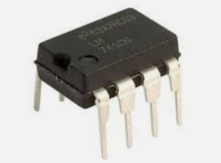

The op-amp is a used to amplify the small signal of the audio.

**Capacitors**

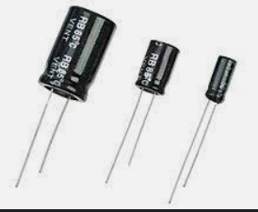

It’s used to limit the bandwidth.

**TIP127 and TIP 122 Transistor**

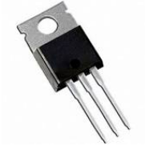

Since op-amp is able to amplify the voltage but not drive much current, which is required for the operation of the load component, power transistor is used.

**Speaker**

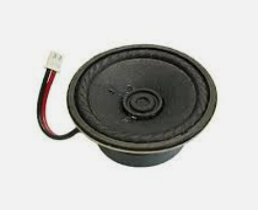

Used to listen to the output amplified sound signal.

**Resistors**

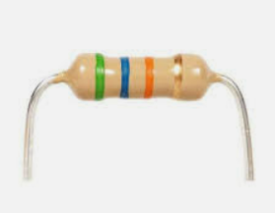

Used to bias the transistors in the right biasing conditions in order to get amplification.

**Bread Board and Connecting Wires**

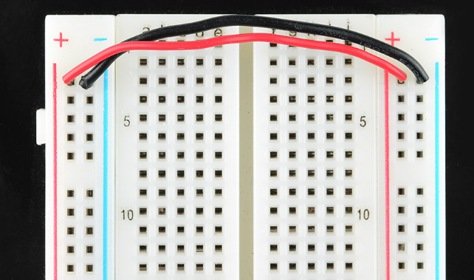

Used for assembly of circuit.

**AUDIO AMPLIFIER USING OP-AMP AND POWER TRANSISTORS**

**KUNAL KESHAN - RA2011004010051**

**GANNI LIKHIT - RA2011004010048**

**MUKTHPURAM SIVARAM CHANDRAN- RA2011004010049**